# *ASSIGNMENT 03*

# ANALYSIS & APPLICATION OF STARTUP FINANCIAL STRATEGIES

**Student Name:** Muhammad Tahir  
**Roll Number:** K214503  
**Date: :** Sunday, April 20, 2025

**1. INTRODUCTION**

This report analyzes the financial strategies of Ikhwa Tech, a software startup focused on innovative software solutions co-founded by Sir Abdul Qadir. The interview covered their funding, cost management, pricing, and scaling decisions. We will:

* *i. Compare their approach with Software Engineering Economics (SEE) principles.*
* *ii. Suggest improvements based on cost models (COCOMO), ROI, and budgeting.*

**2. ANALYSIS: IKHWA TECH VS. SEE PRINCIPLES**

**2.1 FUNDING & BUDGETING**

**Ikhwa Tech’s Approach:**

* Used personal savings, angel investors.
* Budget allocation:
  + 45% → Product development
  + 30% → Hiring engineers
  + 25% → Pilot testing

**Comparison with SEE Principles:**

SEE recommends a structured project estimation process, resource allocation based on work breakdown structures (WBS), and life-cycle costing across planning, development, and maintenance.

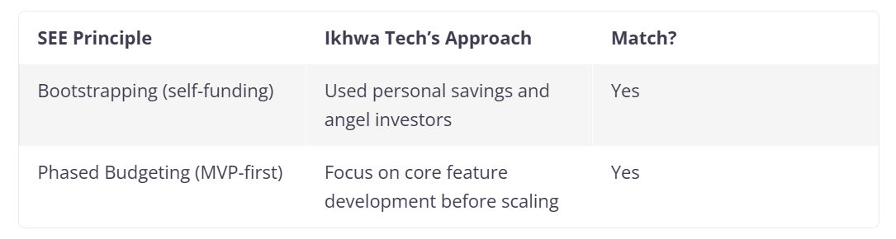

**Gaps in Funding and Budgeting:**

* No formal cost estimation (e.g., COCOMO or Function Point Analysis).
* No historical data or analogous estimation used.
* Lack of cost tracking tools to monitor actual vs. estimated budgets.
* Staff hired were mostly fresh graduates (COCOMO considers team capability as a factor).

**2.2 COST MANAGEMENT**

**Ikhwa Tech’s Approach:**

* Outsourced marketing & non-core tasks.
* Used open-source tools and negotiated cloud discounts or used Free APIs to test.
* Agile sprints used to control scope and budget iteratively.
* Negotiated discounts on cloud services.

**Comparison with SEE Principles:**

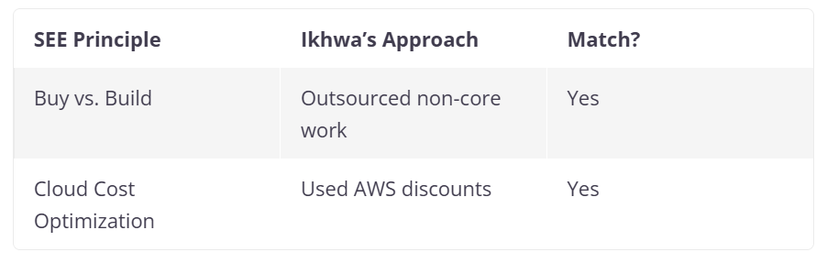

**Gaps in Cost Management:**

* No contingency or buffer budget for unforeseen risks (recommended: 10–15%).
* No formal risk management plan for vendor failure or scope creep.
* No cost baseline defined to measure variances.
* No economic analysis to compare outsourcing vs. in-house execution long-term.
* No reuse strategy or component-based cost reduction, a key SEE recommendation.

**2.3 PRICING MODEL**

Ikhwa Tech develops large, modular software systems primarily tailored for enterprise use. These solutions follow a **component-based model**, where client companies can select and purchase only the modules relevant to their operations—similar to customizable CRM platforms.

**Available modules include:**

1. **Financing** – Tools for budgeting, invoicing, and financial reporting.
2. **Operations Management** – Workflow optimization, task tracking, and resource planning.
3. **Aviation-Specific Functions** – Modules designed for flight operations, scheduling, compliance, and aviation logistics.

**Comparison with SEE Principles:**

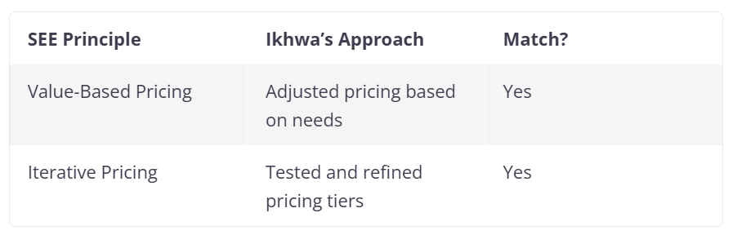

**Gaps in Pricing Model:**

* No formal ROI calculation for pricing tiers.
* No price sensitivity analysis or competitor benchmarking.
* Lack of modeling on how pricing affects market penetration and churn.
* No scenario analysis for future revenue streams.
* No consideration of software license vs. subscription model trade-offs.

**2.4 SCALING & INVESTMENT**

**Ikhwa Tech’s Approach:**

* Early investments came from **family and friends**, many of whom were affiliated with companies operating outside Pakistan, particularly in the **UAE**, which provided not only capital but also potential business networks for future expansion.
* Cloud (AWS) saved 30% costs and handled traffic spikes.

**Comparison with SEE Principles:**

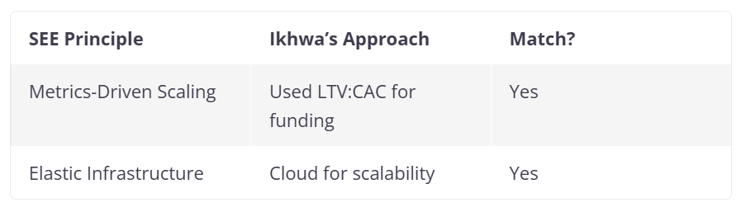

**Gaps in Scaling and Investment:**

* No long-term cost analysis (Cloud vs. On-Premise).
* No DevOps or infrastructure automation costs considered in growth forecasts.
* No technical debt budgeting as they scale features rapidly.
* No alignment of global expansion (e.g., UAE links) with product localization or compliance planning.

**3. RECOMMENDATIONS**

**Budget Allocation Comparison: Ikhwa Tech vs. SEE Recommendations**

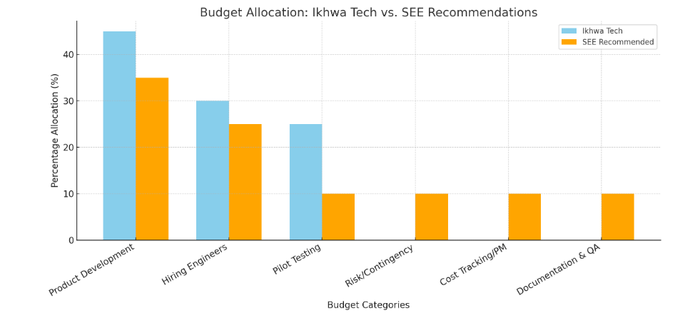

This graph clearly highlights where Ikhwa Tech is over- or under-investing compared to SEE best practices. Notably:

* **Overallocated to Pilot Testing** and **Product Development**
* **No allocation** for **Risk/Contingency**, **Cost Tracking**, or **Documentation & QA**

Based on SEE best practices, Ikhwa Tech should:

**3.1 Use COCOMO for Cost Estimation**

* Formula:

Effort = a × (KLOC)^b

* Example: If MVP = 10,000 LOC, calculate exact dev effort and cost.

**3.2 Add a Risk Budget (10–15%)**

* Covers delays, outsourcing failures, payment issues.

**3.3 Calculate ROI for Pricing**

* Formula:

ROI = (Net Profit / Investment Cost) × 100

* Example: Mid-tier costs $50 K but earns $20 K/month → ROI = 300% in 3 months.

**3.4 Compare Cloud vs. On-Premise Costs**

* Use a 5-year projection to compare hosting options.
* Include operational, maintenance, and downtime costs.

### 3.5 Adopt Cost Tracking Tools

* Integrate budgeting tools (e.g., Jira + Cost tracker, or Costlocker) for real-time financial visibility.

### 3.6 Improve Hiring Strategy

* Mix junior and senior talent to balance costs with experience.
* Use productivity multipliers in estimation models based on team composition.

**4. CONCLUSION**

Ikhwa Tech’s financial strategy shows promising alignment with SEE principles through Agile budgeting, tiered pricing, and cloud-first scalability. However, applying formal models like COCOMO, adding ROI evaluation, risk buffers, and long-term infrastructure planning would strengthen their financial resilience and strategic depth. Their case illustrates how theory and real-world startup agility can be effectively blended with minor refinements.

**5. REFERENCES**

1. Interview with Sir Abdul Qadir, Ikhwa Tech (18 April 2025)
2. Boehm, B. (1981). *Software Engineering Economics* (COCOMO model)
3. AWS Pricing Case Studies